**MAKEREREUNIVERSITY**

**COLLEGE OF ENGINEERING, DESIGN, ART ANDTECHNOLOGY**

**SCHOOL OF ENGINEERING**

**DEPARTMENT OF MECHANICAL ENGINEERING**

**BACHELOR OF SCIENCE IN MECHANICAL ENGINEERING**

**FINAL YEAR PROJECT**

**DEVELOPING A MODEL FOR ESTIMATING GLOBAL IN-PLANE SOLAR IRRADIANCE FOR UGANDA**

**NAME: KALIBALA ABDUNOOR**

**REGISTRATION NUMBER: 15/U/5579/PSA**

**STUDENT NUMBER: 215005469**

**MAIN SUPERVISOR: Mr. MUJJUNI FRANCIS.**

**CO-SUPERVISOR: PROF. MACKAY OKURE**

# DECLARATION

I **KALIBALA ABDUNOOR** solemnly declare that every aspect of this report is a true account of all the activities I was involved in during the 12 months period of final year project.

………………………………. ……………………………

Signature Date

**SUPERVISED BY:**

**MAIN SUPERVISOR**

**Mr. MUJJUNI FRANCIS**

Sign: …………………………

Date: …………………………

**CO-SUPERVISOR**

**PROF. MACKAY OKURE**

Sign: …………………………

Date: …………………………

# DEDICATION

I dedicate this report to my brother Mr. Mukiibi jimmy who encouraged, supported and guided me academically and financially throughout the whole period of four grueling years. I also dedicate this report to netLabs!UG at Mekerere University for providing machine learning environment that helped me to crunch up huge datasets for my project.

# ACKNOWLEDGMENT

I would like to thank Makerere University, College of Engineering, Design, Art and Technology, particularly the Department of Mechanical Engineering for giving me the opportunity to engage in this final year project, which has helped me gain a wide range of knowledge about different Solar models for estimating in plane irradiance and enhancing my coding skills to another level.

I am very grateful to the entire department staff, especially the lecturers whom have been there for me for the whole four years, helping me, educating, instilling confidence and above all preparing me for the future. God should reward you abundantly.

I would like to also send my gratitude to members of Absolute Energy and department of Physics at Makerere university Kampala for providing solar data which was indispensable for this project to me, thank u so much for your support, may God bless u.

Great appreciation to my project supervisor Mr. Mujjuni Francis, for the academic and intellectual support you offered to me and especially the jokes. I would like to thank you for the time you offered me to minimize unanticipated eventualities that would result in delay of my final year project, the time you spent to reading through my proposal, my final project report and the time you took to go through the code . I would like to further thank you for the advice, both academic and social, that you gave me. The only way I could show my appreciation is by praying that Allah blesses you abundantly.

My final gratitude goes to my family, who through hard times believed in me, gave me courage, confidence, support and advised me to keep working harder till I achieve my dream. Thank you so much.

# ABSTRACT

The project was focused on evaluation of the accuracy of combination of models that estimate plane-of-array (POA) irradiance from measured global horizontal irradiance (GHI), developing a decomposition model to estimate beam and diffuse horizontal irradiance and ascertaining optimum orientation of a solar collector for any given location in Uganda.

The most widely used decomposition models were developed using empirical formulas and several parameters which were determined using datasets of a single location, these models do not necessary fit in every datasets of different locations due to discrepancies in environmental conditions. This estimation involves decomposition of global horizontal irradiance (GHI) into beam horizontal irradiance (BHI) and diffuse horizontal irradiance (DHI) components, then transposition of beam and diffuse global horizontal components into POA irradiance. Developing a model for estimating global in-plane irradiance involves two steps: (1) Developing decomposition model using diffuse fraction and clearness index with BHI, GHI and extraterrestrial irradiance as inputs. (2) Coupling transposition models with developed decomposition models to predict plane of array irradiance.

Measured GHI and respective measured POA irradiance were used to evaluate combination of clear-sky, decomposition and transposition models to quantify relative mean bias deviation and root mean square deviation and the combination with the smallest relative mean square deviation was selected for further optimization analysis to obtain tilt angle and surface azimuth that yields maximum annual irradiation. Results suggests that for collector facing south and tilted should be left flat to yield maximum irradiation and the optimal tilt and surface azimuth angle was about 11 and 82 degrees respectively for regions near the equator.

The best performing combination of models consisted clear-sky model of Duffie and Beckman, the decomposition model that was developed using local datasets and transposition model of Perez. This combination had 2.2% and 35% relative Mean bias deviation and relative root mean square bias deviation respectively. The optimal parameters that yield maximum deviation applies for north of equator regions since this project never had enough data for regions in south of equator to quantify optimal parameters that yield maximum annual irradiation. The developed model performed well compared to other models on basis of relative root mean bias deviation and relative root mean square deviation and it performs well annual data with R2 of 0.98.

TABLE OF CONTENTS

DECLARATION i

DEDICATION ii

ACKNOWLEDGMENT iii

ABSTRACT iv

LIST OF TABLES vii

LIST OF ACRONYMS vii

1.0 INTRODUCTION 1

1.1 Background 1

1.2 Problem Statement 2

1.3 Objectives 2

1.3.1 Main Objective 2

1.3.2 Specific Objectives 3

1.4 Scope 3

1.5 Justification 3

1.6 Research Questions 3

2.0 LITERATURE REVIEW 4

2.1 Clear-Sky Models 4

2.1.1 Solar position 4

2.1.2 Extraterrestrial Radiation 5

2.2 Decomposition Models 5

**2.3 Transposition Models** 7

2.4 Ground Reflected Diffuse 9

2.5 Model Validation/Comparison 9

3.0 METHODOLOGY 10

3.1 Context 11

3.2 Modeling Environment and structure 11

3.3 Data Description 11

3.4 Data Acquisition and Analysis 11

3.5 Model Development 13

3.6 Limitations 13

3.7 Research design 14

4.0 ANALYSIS AND RESULTS 15

4.1 Model Selection 15

4.2 Developing Decomposition Model 15

4.3 Adjusting Collector Tilt 20

4.4 Adjusting Surface Azimuth Angle 23

4.5 Adjusting both Collector tilt and Surface azimuth angles 26

4.6 Sun Hours for different regions 29

4.7 Summary of Results from Analysis 29

5.0 CONCLUSION AND RECOMMENDATIONS 30

5.1 Conclusion 30

5.1 Recommendations 30

APPENDIX 31

BIBLIOGRAPHY 32

# LIST OF TABLES

Table 1: Constants for Estimating and as a function of ε 13

Table 2: Albedo for Different Types of Surface 14

Table 3: Summary of different models detailed from above 14

Table 4: Data Locations 17

Table 5: Model combinations 23

# 

# LIST OF ACRONYMS & SYMBOLS

– Angle of declination

– Hour angle

h – Angle of Elevation

– Solar azimuth

– Angle of incidence

– Zenith Angle

– Solar Constant

– Clearness index

– Diffusion fraction

𝜶 – collector tilt

- albedo

AM – air mass

- Global horizontal irradiance

- Extraterrestrial horizontal irradiance

– Extraterrestrial irradiance

, - DHI- Beam Horizontal Irradiance

, - BHI – beam irradiance on inclined plane

- Direct irradiance

, GHI- Diffuse horizontal irradiance

– diffuse irradiance on inclined plane

, - POA – Plane of array irradiance

– Diffusion fraction

- Clearness index

Ms – Micro Soft

– diffuse reflected component

rMBD – Relative Mean bias deviation

rRMSD – Relative Root Mean square Deviation

– Latitude

– Longitude

– Surface azimuth

# 

# 1.0 INTRODUCTION

## 1.1 Background

In recent centuries there has been effort of harnessing solar energy by converting it into electricity. If solar energy is efficiently used, it will decrease the total world energy demand which increases daily currently at 2.1% [1]. This has triggered need to do research on photovoltaic (PV) cells that usually convert solar energy into electricity and has gravitated most scientist to work around the clock to come up with models which quantify solar irradiation incident on PV cells which will enhance the accuracy in deterministic energy models used in PV plant design and performance analysis.

Number of mathematical models e.g. Perez[2], Hay and Davies [3], Klucher [4], Erbs [5] , Duffie and Beckman [6] have been developed to estimate plan of array (POA) irradiance[1] since this is what is based on performance analysis of the PV modules. However there is some uncertainties such as isotropic model of Duffie and Beckman[6] that assumes all diffuse radiation (DHI)[2] is uniformly distributed over the sky dome and reflection on the ground is also diffuse ignoring circumsolar diffuse component[3][7], Erbs computes diffuse radiance using diffusion fraction that depends on empirical formula rather developed on data collected from stations in USA.

Models that predict plane of array (POA) irradiance from global horizontal irradiance (GHI) [8] are indispensable for performance analysis of photovoltaic PV modules to get optimal tilt and surface azimuth angle[4] that maximizes irradiance received on PV collectors. These models also quantify radiation incident on solar dryers that are used in drying vegetables and crops to enable designers to quantify volume of air that is required for drying at a requisite dryer temperature [9]. The solar radiation incident on inclined surface is also used in solar water heating systems to determine the amount of useful heat energy extracted by water.

Modeling in-plane irradiance from global irradiation involve first, decomposing GHI into diffuse horizontal irradiance (DHI) [8]and beam horizontal irradiance (BHI) [5] ([5], [10] , [11], [12]) with clearness index and extraterrestrial irradiance derived by several models by Spencer [13], Duffie and Beckman [6]. Subsequently, transposition of these components using Perez [2], Liu and Jordan [14], or Hay and Davies [3] into POA components [15] such as diffuse and beam components on tilt surface. Lastly, the latter components are merged together by summing them to get measured POA irradiance.

However these models such as ([16], [4], [5] and [6]) were developed using factors such as clearness index that intrinsically depends on dust particles, clouds and water vapor, of single location that is not necessarily uniform in every location of the globe. The proposed model is to be developed basing on the local atmospheric factors that affect ground observed irradiance and ultimately facilitate in quantifying a POA irradiation with perhaps less uncertainties and optimum tilt angle which maximize POA radiation received.

The purpose of the proposed study is to validate these models on tilt surface based on local condition such as weather, relative humidity and air pollution. Ultimate goal of this work is to review these models against data sets collected from Uganda in order to predict plane of array POA irradiation incident on solar collectors. The hourly or daily global horizontal irradiation GHI data collected from different sites in Uganda from which hourly averages of global horizontal irradiation GHI[6] is obtained to be used as input in the models.

## 1.2 Problem Statement

In the PV systems design analysis, the cardinal input parameter is the solar insolation received on solar module oriented towards south for a system in northern hemisphere or for one north in the south hemisphere to get maximum power received annually. If solar irradiance incident on the surface is erroneously predicted, it will affect the calculated total energy yield impinging on project’s financial returns.

When the PV systems components are designed basing on inaccurate daily or annual insolation, this subsequently leads to either over or under sizing of the components used and cost will commensurate with component size therefore increasing/underestimating capital cost and the period of payback or reduce the system’s reliability. This eventually might frustrate the developers’ financial expectations and the end user supply systems reliability.

Most widely used models were developed using empirical formulas and the several parameters which were determined using data sets of a single location. These models do not necessary fit in every datasets of different locations due to discrepancies in environmental conditions for example Orgill and Holland’s (1977) model used data from Canadian stations where they have winter and summer seasons and atmospheric conditions such as air pollution and relative humidity that influence clearness index function used in modelling beam and diffuse horizontal irradiance components, are not necessarily similar in to Uganda.

## 1.3 Objectives

## 1.3.1 Main Objective

The main objective of this project is to develop a model for estimating global in-plane solar irradiance for Uganda that will reduce uncertainties in quantifying solar radiation received on inclined planes.

## 1.3.2 Specific Objectives

* Review the available models for plane of array determination using revised model
* Evaluate hourly solar irradiation received on plane of array installation
* Validate the model plane of array estimations against measured data
* Ascertain the optimal orientation of a solar collector for any given location in Uganda

## 1.4 Scope

The project entails developing a computer program based model using Python programming language for estimating annual hourly global in-plane solar irradiance for Uganda and quantifying optimum angle of inclination and azimuth orientation for maximum power received on collector surface. The model will be applicable to both southern and northern hemisphere parts of the country (i.e. Kabale to Moyo) and the program will receive hourly based global horizontal irradiance , the computed values will be outputted in excel sheets.

## 1.5 Justification

Most PV systems, solar water heating systems and solar driers are susceptible to problems such as inefficiency, improper sizing of system components and low power yield compared to the expectations of developers. Developing a model that estimates in-plane irradiance using local atmospheric conditions will remedy some problems and provide the following advantages.

* Potentially, improved solar energy will be harnessed from installed systems due to optimized orientation and tilt angle of in-plane surfaces selected.
* Reduction in capital costs is anticipated since the systems might require components well matched to the available resource.
* This model is bound to curtail on the uncertainties realized during the design and installation of PV and solar thermal systems.
* The model will estimate average monthly solar irradiation for Operations & monitoring modes

## 1.6 Research Questions

* What are the available models and chronological approach for estimating in-plane irradiation?
* What parameters increase uncertainties when the available models are employed in different areas?
* What are key problems challenging existing models?
* Which kind of tools are being used in measuring solar irradiation data used?
* How do various parameters affect model accuracy in different areas?
* What is the quantity and quality of data needed to develop a model?
* What are the key parameters to yield maximum solar irradiation on inclined surfaces annually?

# 2.0 LITERATURE REVIEW

## 2.1 Clear-Sky Models

## 2.1.1 Solar position

Most clear sky models frequently rely on solar geometry and extraterrestrial irradiation. The intensity of the sun on earth’s surface depends on geographic location on earth’s surface, time and elevation of the sun[17] relative to the observer on earth . The geometry of solar input parameters into sky models are angle of incidence, angle of declination, hour angle, angle of elevation and solar azimuth.

1. **Angle of Declination (**δ**)**: This is the angular position of the sun at solar noon[7] with respect to the plane of equator and usually vary between -23.45° and 23.45°. Using (Cooper 1969) [18] equation, declination angle is given by

δ = 23.45

Where DoY is day of the year

1. **Hour angle (**ω**)**: This is the angular displacement of the sun east or west of local meridian due to rotation of the earth[19] around it axis . Hour angle in degrees is given by following equation.

ω = 15(solar time – 12)

Using standard solar time equation derived analytically

Solar time = standard time + E + 4( -)

Where is local longitude

is standard Meridian for local time

E is equation of time given by

**(Tasdemiroglu 1988) model**  [20]

E = 9.87 – 7.53 – 1.5

Where B =

1. **Angle of Elevation (h)**: This is the angle between the sun ray to the observer and projection line on the horizontal plane.

The angle of elevation derived analytically is given as follows

= +

Where h is angle of elevation, is angle of declination, is latitude

1. **Solar azimuth (**): This is the angular displacement from south of the projection beam radiation on horizontal plane[19].

Using derived mathematical analytical equation, solar azimuth is given by [21]

=

Where is solar azimuth

1. **Angle of incidence ()**: This is the angle between sun ray on the surface and normal to the incidence[22].

Using derived mathematical analytical equation, angle of incidence is given by [21]

= - + + +

where ϑ is angle of incidence, is surface azimuth

## 2.1.2 Extraterrestrial Radiation

This is the radiation that reach outer part of atmosphere in the outer space which varies slightly thought the year because the distance between the earth and sun vary thought the year due to elliptical orbital path of the earth around the sun. There are various models that estimate extraterrestrial radiation such as Duffie and Beckman [6], Spencer [13] and asce [23]

1. **Duffie and Beckman model** [6]

GET, h = Io

Where GET, h is extraterrestrial radiation on horizontal plane, Io is solar constant and equals to 1367

1. **Spencer Model**

This function computes extraterrestrial irradiance on horizontal surface in earth atmosphere based on Fourier representation[24] of the position of earth [25].

GET, h = Io(1.000110 + 0.034221 + 0.001280 + 0.000719 + 0.000077)

= (DoY – 1)

1. **ASCE Model** [23]

GET, h = Io

## 2.2 Decomposition Models

Decomposition models estimates the fraction Beam and diffuse horizontal irradiance from measured Global horizontal irradiance. The cardinal input of these models are Global horizontal irradiance (GHI) and Clearness index Kt. Clearness index is the function which compute global horizontal clearness index with respect to the extraterrestrial irradiance on horizontal plane [24]

1. **Erbs Decomposition Model**

Erbs model was developed on data collected from five different stations in USA at different latitudes between 31°and 42°. The model uses diffusion fraction which is the ratio diffuse horizontal irradiance to Global horizontal irradiance to estimate diffuse irradiance [26]. Solar irradiation on horizontal plane is the sum beam and diffuse horizontal irradiance

= +

=

Where =

1. **Orgill and Holland’s Decomposition Model**

This model estimates diffuse and beam irradiance on horizontal plane with clearness index and diffuse fraction as its cardinal inputs. The model was developed on diffuse irradiance collected and global horizontal irradiation from Toronto [10].

=

1. **Boland’s Decomposition Model**

Boland’s model is a mathematical approach which was employed for evaluation based on data gathered in Victoria, Austria. The model comprises a simple exponential correlation, it evaluate diffuse irradiance for any clearness index [27].

=

1. **Muneer’s Decomposition Model**

Muneer et al model established a correlation between diffuse irradiation and global horizontal irradiance in New Delhi, India [28].

=

## **2.3** Transposition Models

Solar irradiation incident on inclined collector can be subdivided into the beam from sun disc on tilt surface and diffuse component resulting from scattering caused by gas particles, water vapor and dust particles. The total irradiance on the inclined collector is the sum of beam and diffuse component incident on the collector and reflected diffuse component.

= + +

1. **Liu and Jordan model**

This isotropic model presumes that diffuse radiation is constant over the whole sky and is given by the following equation [29].

= () ×

1. **Hay and Davies Model**

Hay and Davies model predicted diffusion radiation on an inclined model as follows with inclusion of anisotropic indexas follows [3].

= =

=

1. **Klucher Model**

Klutcher found out that isotropic models give good results for overcast skies but under estimates irradiance under clear sky and partly overcast. The Klutcher model refined with inclusion of function that determine cloud cover [4].

= 1-2

=

where is zenith angle, is angle of incidence and is angle of tilt

1. **Perez model**

Perez model subdivide the radiation into isotropic diffuse, circumsolar and horizon brightness radiation using empirically derived coefficients [30].

=

The coefficients a and b are given by

a = max (0,)

b = max (,

The sky clearness ε and brightness ∆ are given by

=

ε =

In degrees

∆ = AM Where is extraterrestrial radiation

=

AM =

Bright coefficients and are computed as follows

= max

=

And values are read in the table 1 below

Table 2:1 Constants for Estimating and as a function of ε

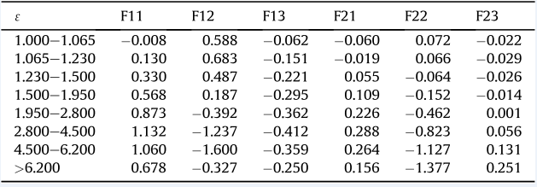

Source: Perez et al, 1990[31]

1. **Direct Irradiance on tilt surface**

The calculation of beam irradiance on tilted collector is purely geometrical and is given by:

=

## 2.4 Ground Reflected Diffuse

The ground reflected diffuse is typically estimated from global horizontal irradiance, ground albedo and surface tilt from horizontal.

Table 2:2 Albedo for Different Types of Surface

|  |  |  |  |
| --- | --- | --- | --- |
| **Surface** | **Albedo** | **Surface** | **Albedo** |
| Grass (Summer) | 0.25 | Asphalt | 0.15 |
| Lawn | 0.18-0.23 | Woods | 0.05-0.18 |
| Dry grass | 0.28-0.32 | Heathland and sand | 0.10-0.25 |
| Uncultivated fields | 0.26 | Water surface (h > 45) | 0.05 |
| Soil | 0.17 | Water surface (h > 30) | 0.08 |
| Gravel | 0.18 | Water surface (h > 20) | 0.12 |
| Concrete, weathered | 0.20 | Water surface (h > 10) | 0.22 |
| Concrete, clean | 0.30 | Fresh snow cover | 0.80-0.90 |
| Cement, clean | 0.55 | Old snow cover | 0.45-0.70 |

Source: Dietz, 1957, TUV 1984 [32]

**(Geuymard 2009) model** [33]

= Where is albedo

Table 2:3 Summary of different models detailed from above

|  |  |  |
| --- | --- | --- |
| **Clear Sky models** | **Decomposition models** | **Transposition models** |
| Duffie and Beckman | Erbs | Perez |
| Spencer | Orgill and Holland | Hay and Davis |
| ASCE | Boland | Liu and Jordan |
|  | Muneers | Klucher |

## 2.5 Model Validation/Comparison

To compare performance of a model, two statistical error function are used to evaluate these models as follows.

1. **Relative Mean bias deviation (rMBD)**

rMBD = ( )

= measured plane of array irradiance

= modeled plan of array irradiance

n = numbers of pairs used

= mean measured plane of array irradiance

1. **Relative Root Mean Square Deviation (rRMSD)**

rRMSD **=**

rRMSD is used for indicating discrepancies between short term modeled values like hourly, daily and monthly whereas rMBD relates annual differences. The best performing combination of models will evaluated on rRMSD.

# 

# 3.0 METHODOLOGY

This section summarizes the data collection techniques, optimization of the developed model and procedures taken to achieve ultimate goal of this project.

## 3.1 Context

After analyzing and assimilating different techniques other researchers used to develop in-plane solar radiation model of different regions. The project was focused on developing model basing on intrinsic parameters/condition instigated locally by the climate changes in Uganda.

## 3.2 Modeling Environment and Structure

The decomposition model was developed using scikit-learn [34], python third party library for machine learning using jupyter notebook as development environment assuming clear-sky conditions with clearness index and diffusion fractions as modeling parameters. The developed models were later programmed using python programming language to combine it with clear sky and transposition models. The development was accomplished by Using Pandas [35], third party library of Python to do data cleaning, preparation and Data wrangling. The resulting data was feed into Python developed models for optimization, development and selection of model and output in MS excel. The resulting best performing combination of models receive global horizontal irradiance, latitude, longitude, surface azimuth and collector tilt as input parameters and outputs plane of array irradiance.

## 3.3 Data Description

The data which was used in developing the model was hourly averaged values of the plane of array irradiance, ambient temperature, Global Horizontal irradiance, Beam Horizontal irradiance, Diffuse Horizontal irradiance, collector tilt, collector azimuth, latitude and longitude of the devices measuring the data. The temperature was in Degree celecius whereas irradiance was given in W/𝑚^2.

## 3.4 Data Acquisition and Analysis

The first batch of datasets was obtained from Absolute Energy from Kitobo weather station. The data included global and plane of array horizontal irradiance which was given in W/m2, temperature in degrees and the plane of array angle was 20. The data which was provided from this weather station was in 5-minute intervals of plane of array irradiance and global horizontal irradiance spanning between 1st august 2017 to 22nd October 2018 measured using solarimeter and pyranomter. There was about 2.6% of the data with missing irradiance values and 26% of data, global horizontal irradiance was extremely lower than plane of array irradiance. This data needed to be prepared so that it is subjected to various models.

The second batch of datasets was obtained from Makerere University Physics department met station. The datasets includes solar irradiance from Kampala, Mbarara, Tororo and Lira sites. The data is summarized below in the table

Table 3:4 Data Locations

|  |  |  |  |  |  |  |
| --- | --- | --- | --- | --- | --- | --- |
| **Station** | **Region** | **Measured Data** | **Time Period** | **Surface Tilt ()** | **Surface Azimuth ()** | **Location** |
| 1 | Kampala | GHI,POA,BHI,DHI | 2008-2019 | 30,15,22.5 | 0 | 0.3370°N, 32.5657°E |
| 2 | Mbarara | GHI,BHI,DHI | 2009-2016 | 0 | N/A | 0.6072°S, 30.6545°E |
| 3 | Tororo | DHI,BHI | 2008-2017 | 0 | N/A | 0.6782°N, 34.1866°E |
| 4 | Lira | DHI,BHI | 2008-2011 | 0 | N/A | 2.2581°N, 32.8874°E |
| 5 | Kitobo | GHI,POA | 1/8/2017-22/9/2018 | 20 | 15 | 0.2600°N, 32.4315°E |

The project analysis was based on evaluation of accuracy of the combination of clear-sky, decomposition and transposition models using GHI as an input and computed POA was compared to measure POA. The DHI and BHI estimated from decomposition models was used as inputs into the transposition models and later developing a model estimating plane of array irradiance.

The measured data was summarized into hourly averages because the considered models were designed to predict hourly values. The analysis was focused on model combinations which are globally mostly used and prominent decomposition and transposition models.

The timestamps which had missing GHI or POA values were excluded from the analysis. Also local data-time was converted to timestamp zone aware before converting it into GMT time since available models use standard time. Some POA irradiance measurement were extremely greater than GHI measurement thus both results were reflecting disparity in weather conditions at same time contradicting whether there was clear sky or overcast conditions, the data was excluded because values would be likely as results of data collection errors. All GHI, BHI, DHI values less than 0 W/ were removed from the analysis, since the values were likely erroneous measurement. Additionally, any BHI or DHI that exceeded concurrent GHI measurement was set equal to the GHI measurements because it is not physically possible for either irradiances to exceed GHI.

Some quality control were carried out at some locations. Data from Mbarara exhibited some inconsistences from 2012 were the devices were measuring big irradiances at night and very small GHI compared to the BHI. The pyrometers which were measuring GHI were not working for some number of months intermittently and it was precarious to include such data for analysis. The Datasets from Tororo starting showing inconsistences from Jan 2012 to Dec 2012 were the devices were recording large irradiance values at night which is physically impossible, such data was excluded from analysis

## 3.5 Model Development

Developing in-plane model began with, Decomposition model which was developed from available diffuse horizontal solar irradiance datasets by developing a mathematical relationship between diffuse fraction and clearness index which is greatly influenced by local climate, dust particles and other elements in the atmosphere.

Subsequently, output from decomposition model were used as input for transposition models to compute beam and diffuse horizontal irradiance on tilted collector. The later output components are summed to compute plane of array irradiance.

The measured POA irradiance was compared to computed POA irradiance to quantify rMBD and rRMSD errors for different combination of models and combination with small rRMSD was used for further analysis i.e. optimization to get optimal collector tilt and azimuth angle for maximum that yield maximum irradiation.

## 3.6 Limitations

* Since in this project the data from southern hemisphere was not enough to be fully represented, there was only one region from southern hemisphere, the developed model is suitable to be used for parts of Uganda north of equator.

## 3.7 Research Design

**Input Process Output**

* Solar geometry
* Location
* Time and Date
* Angle of incidence
* List of tilt angle
* List of angle of collector Azimuth
* Measured in-plane Irradiance
* Predicted PoA Irradiance
* Surface Tilt
* Surface azimuth
* Air mass
* GHI
* KT
* Clearness index function

Global Horizontal Extraterrestrial irradiance GHIET, h

* BHI
* DHI
* Beam irradiance on tilt surface
* Diffuse irradiance on tilt surface

PoA Irradaiation

**Validation**

* RMSD
* MBD

Selected Model

**Transposition Models**

* Liu and Jordan
* Perez
* Hay and Davies
* Klucher
* Reindl et al (1990)

Clear Sky Models

* Duffie and Beckman
* Spencer
* ASCE

**Decomposition Models**

* Orgil and Hollands
* Erbs
* DISC
* DIRINT

# 4.0 ANALYSIS AND RESULTS

## 4.1 Model Selection

After cleaning and preparing solar Datasets. The cleaned datasets were subjected to different combination of clear sky, decomposition and transposition models which was about 27 combinations randomly selected by a computer program to unbridle datasets from single prominent combination to compute POA irradiance.

The computed POA irradiance was compared with measured POA irradiance to compute relative MBD and relative root mean square deviation errors to select the combination with the smallest bias possible. The combination consist Duffie and Beckman clear sky model, developed decomposition model from local datasets and Perez transposition model with 35.53% relative mean square root deviation. This combination was further used to obtain optimal collector tilt and surface azimuth to get high yield of power annually.

## 4.2 Developing Decomposition Model

Developing decomposition model involves computing diffusion fraction which is the ratio of diffuse horizontal irradiance to global horizontal irradiance and clearness index which is the ratio of global horizontal irradiance to extraterrestrial irradiance. The scatter graph of diffusion fraction against clearness index is plot ted later in which correlation between diffusion fraction and clearness index is obtained using Linear Regression model with the highest correlation coefficient score. The graph of diffusion fraction against clearness index is shown in a figure below.

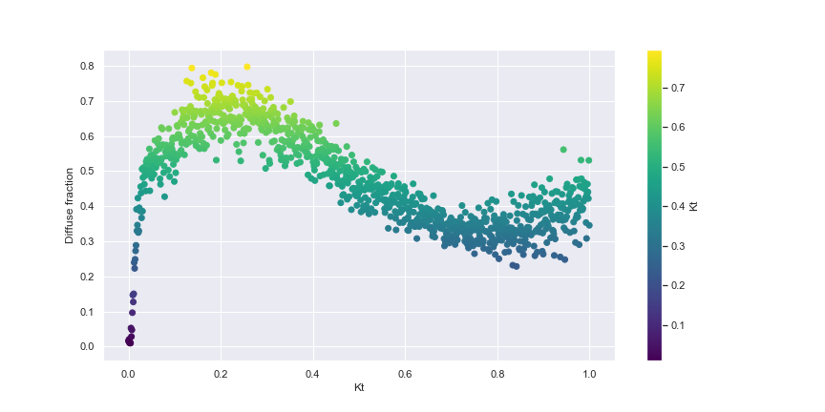

Figure 4:1 The Graph of Diffuse fraction against Clearness index

The correlations between diffusion fraction and clearness index are shown below, these were derived from different solar irradiance datasets collected around Uganda.

**Model 1**

= 0.2522 + 4.5394kt – 15.2958 + 17.32080 – 6.4097

for 0 kt 1

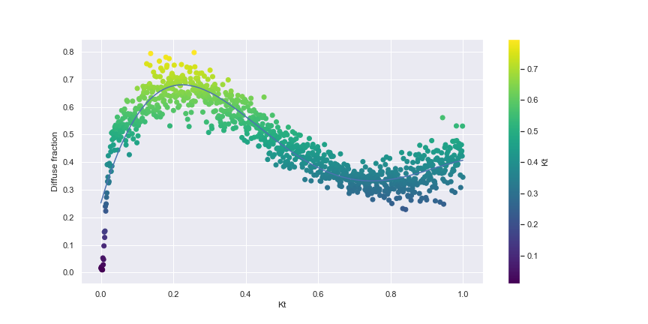

Figure 4:2 The Correlation of Diffuse fraction against clearness index for 0 kt 1

**Model 2**

=

The plots of diffuse fraction against clearness index for different ranges of clearness index is shown below

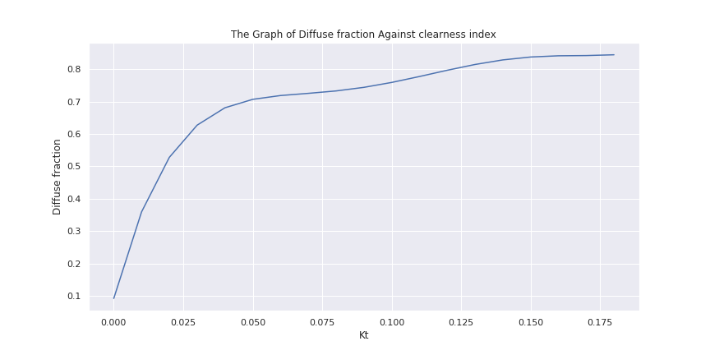

Figure 4:3 clearness index less than 0.2

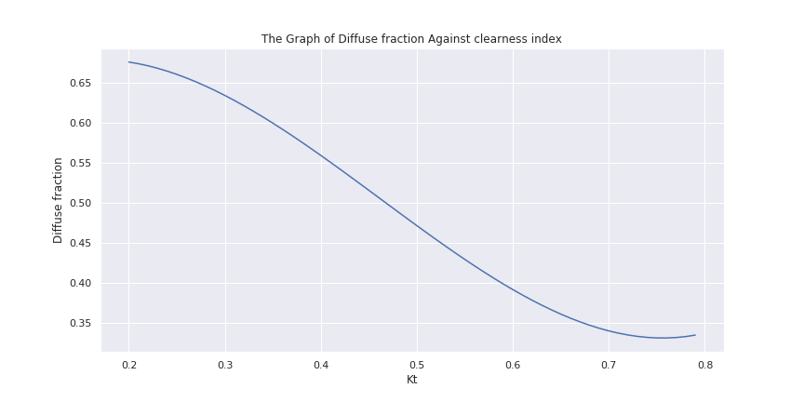

Figure 4:4 Clearness index between

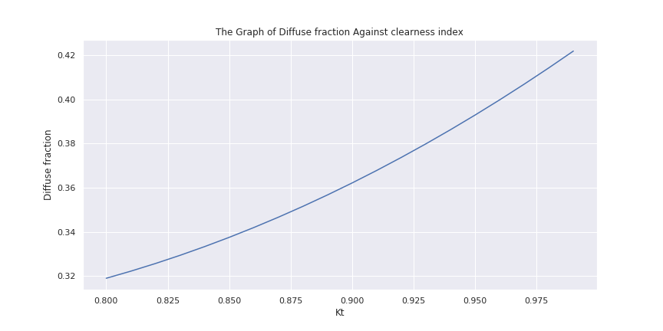

Figure 4:5 Clearness index,

Table 4:5 Model Combinations and Performance

| **S/D** | **Clear-sky model** | **Decomposition** | **Transposition** | **rMBD**  **%** | **rRMSD**  **%** |
| --- | --- | --- | --- | --- | --- |
| 1 | Spencer | Model 2 | Liu and Jordan | 0.30 | 44.94 |
| 2 | Spencer | Model 2 | Hay and Davies | 15.89 | 36.57 |
| 3 | Spencer | Model 2 | Perez | 2.54 | 35.59 |
| 4 | ASCE | Model 2 | Liu and Jordan | 0.30 | 44.93 |
| 5 | ASCE | Model 2 | Hay and Davies | 15.89 | 36.57 |
| 6 | ASCE | Model 2 | Perez | 2.55 | 35.58 |
| 7 | Duffie and Beckman | Model 2 | Liu and Jordan | 0.30 | 44.93 |
| 8 | Duffie and Beckman | Model 2 | Hay and Davies | 15.89 | 36.57 |
| 9 | Duffie and Beckman | Model 2 | Perez | 2.55 | 35.58 |
| 10 | Spencer | Model 1 | Liu and Jordan | 0.78 | 42.52 |
| 11 | Spencer | Model 1 | Hay and Davies | 15.57 | 36.48 |
| 12 | Spencer | Model 1 | Perez | 2.54 | 35.55 |
| 13 | ASCE | Model 1 | Liu and Jordan | 0.78 | 42.51 |
| 14 | ASCE | Model 1 | Hay and Davies | 15.57 | 36.47 |
| 15 | ASCE | Model 1 | Perez | 2.55 | 35.54 |
| 16 | Duffie and Beckman | Model 1 | Liu and Jordan | 0.78 | 42.51 |
| 17 | Duffie and Beckman | Model 1 | Hay and Davies | 15.57 | 36.47 |
| 18 | Duffie and Beckman | Model 1 | Perez | 2.55 | 35.54 |
| 19 | Spencer | Erbs | Liu and Jordan | -11.78 | 1368.33 |
| 20 | Spencer | Erbs | Hay and Davies | -28.0689 | 2034.21 |
| 21 | Spencer | Erbs | Perez | -20.54 | 1294.98 |
| 22 | ASCE | Erbs | Liu and Jordan | -11.79 | 1368.33 |
| 23 | ASCE | Erbs | Hay and Davies | -28.20 | 2035.47 |
| 24 | ASCE | Erbs | Perez | -20.55 | 1294.98 |
| 25 | Duffie and Beckman | Erbs | Liu and Jordan | -11.79 | 1368.33 |
| 26 | Duffie and Beckman | Erbs | Hay and Davies | -28.20 | 2035.47 |
| 27 | Duffie and Beckman | Erbs | Perez | -20.55 | 1294.98 |
| 28 | Spencer | Orgil and Holland | Liu and Jordan | -11.63 | 1348.71 |
| 29 | Spencer | Orgil and Holland | Hay and Davies | -29.98 | 2143.04 |
| 30 | Spencer | Orgil and Holland | Perez | -20.87 | 1276.40 |
| 31 | ASCE | Orgil and Holland | Liu and Jordan | -11.64 | 1348.71 |
| 32 | ASCE | Orgil and Holland | Hay and Davies | -30.13 | 2144.37 |
| 33 | ASCE | Orgil and Holland | Perez | -20.88 | 1276.40 |
| 34 | Duffie and Beckman | Orgil and Holland | Liu and Jordan | -11.64 | 1348.71 |
| 35 | Duffie and Beckman | Orgil and Holland | Hay and Davies | -30.12 | 2144.37 |
| 36 | Duffie and Beckman | Orgil and Holland | Perez | -20.88 | 1276.40 |
| 37 | Spencer | Boland | Liu and Jordan | -15.77 | 1638.25 |
| 38 | Spencer | Boland | Hay and Davies | 11.89 | 138.69 |
| 39 | Spencer | Boland | Perez | -7.94546 | 45.07547 |
| 40 | ASCE | Boland | Liu and Jordan | -15.78 | 1638.25 |
| 41 | ASCE | Boland | Hay and Davies | 11.88 | 138.69 |
| 42 | ASCE | Boland | Perez | -7.94 | 45.02 |
| 43 | Duffie and Beckman | Boland | Liu and Jordan | -15.78 | 1638.25 |
| 44 | Duffie and Beckman | Boland | Hay and Davies | 11.89 | 138.69 |
| 45 | Duffie and Beckman | Boland | Perez | -7.95 | 45.03 |

rRMSD is used for indicating discrepancies between short term modeled values hourly, daily and monthly whereas rMBD relates annual differences. For best performing combination at No. 18 indicates that it performs well on long term values like annual values with 2.5% rMBD and with 35.5% rRMSD on short term values like hourly values.

## 4.3 Correlation Between Predicted and Measured POA irradiance

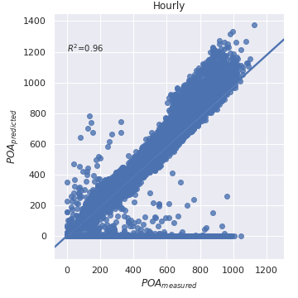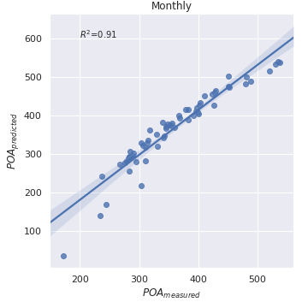

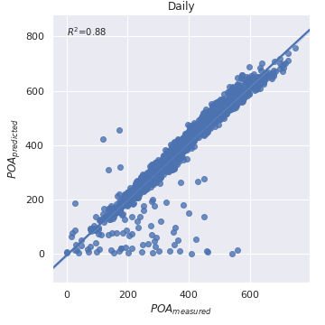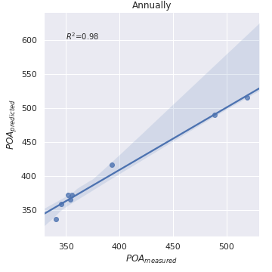

## 4.4 Adjusting Collector Tilt

The collector tilt angle was varied between 0 and 180 degrees using combination with the smallest rRMSD which was No.18 from the table 4:5 while fixing surface azimuth to 0 degrees for northern hemisphere fixing it to face in south and 180 degrees in southern hemisphere fixing it to face north as its recommended in most literature [36]. The average irradiation was computed for each tilt angle and then tilt angle with maximum average annual solar irradiation was obtained for different areas. The plot of average annual irradiation against tilt angle for different areas is shown below.

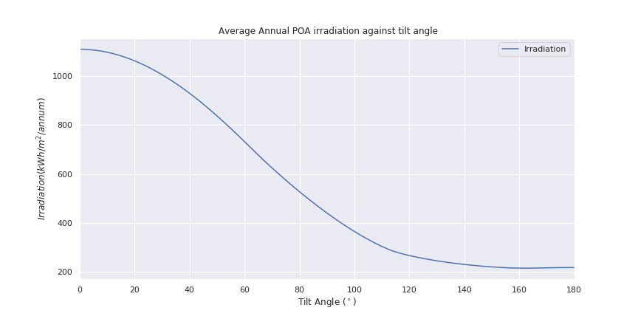

Figure 4:6 Average Annual irradiation on various inclined surfaces in Kampala facing south

The surface which is facing south and near the equator like in Kampala in northern hemisphere, any increase in surface tilt from the horizontal results in reduction of irradiation received per annum on a collector. The average irradiation per annum is maximum at 0 degree surface tilt with surface facing south and corresponding average irradiation is 1110kWh//annum. For regions near the equator with surfaces facing south, the collector should be flat to yield maximum irradiation per year.

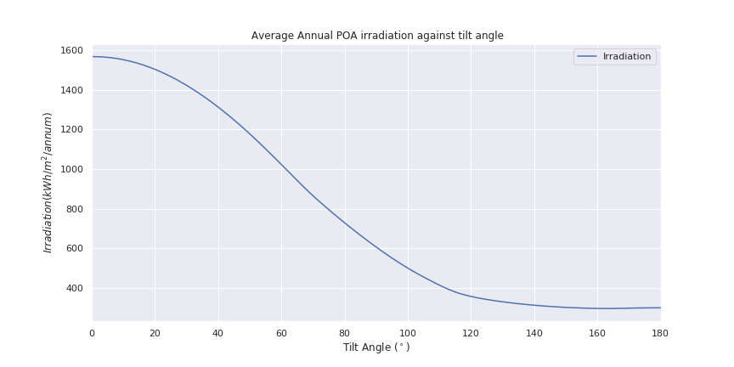

Figure 4:7 Average Annual irradiation on various inclined surfaces in Lira facing south

The surface which is facing south and away from equator in Northern Uganda like Lira, any increase in surface tilt from the horizontal results in reduction of irradiation received per annum on a collector. The average irradiation per annum is maximum at 0 degree surface tilt with surface facing south and corresponding average irradiation is 1570kWh//annum. For regions away from the equator northern parts of Uganda with surfaces facing south, the collector should be flat to yield maximum irradiation per year.

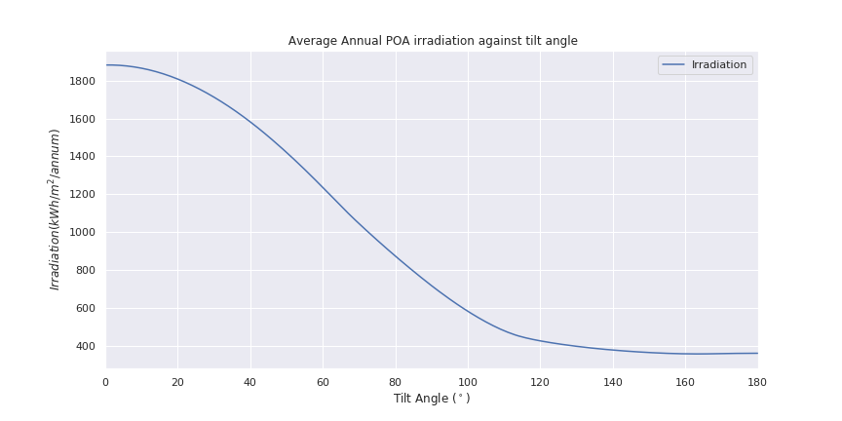

Figure 4:8 Average Annual irradiation on Various Inclined Surfaces in Tororo facing south

The surface which is facing south and away from equator in Eastern Region of Uganda like Tororo, any increase in surface tilt from the horizontal results in reduction of irradiation received per annum on a collector. The average irradiation per annum is maximum at 1 degree surface tilt with surface facing south and corresponding average irradiation is 1874kWh//annum. For regions away from the equator northern parts of Uganda with surfaces facing south, the collector should be flat to yield maximum irradiation per year.

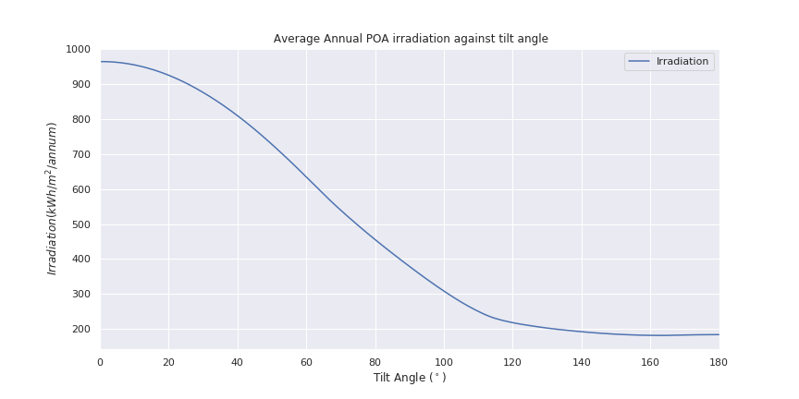

Figure 4:9 Average Annual Irradiation on Various Inclined Surfaces in Mbarara facing north

The surface which is facing north and near the equator in southern hemisphere like Mbarara region, any increase in surface tilt from the horizontal results in reduction of irradiation received per annum on a collector. The average irradiation per annum is maximum at 0 degree surface tilt with surface facing north and corresponding average irradiation is 962kWh//annum. For regions near the equator in southern hemisphere with surfaces facing north, the collector should be flat to yield maximum irradiation per year.

## 4.5 Adjusting Surface Azimuth Angle

The surface azimuth angle was adjusted between -180 and 180 degrees while fixing collector tilt angle at 15 degrees for Kampala, Tororo, Lira and Mbarara. The average annual solar irradiation was computed for each surface azimuth and then surface azimuth angle which corresponds to maximum annual solar irradiation was obtained for different areas, the plots of average annual irradiation against surface azimuth for different areas are shown below.

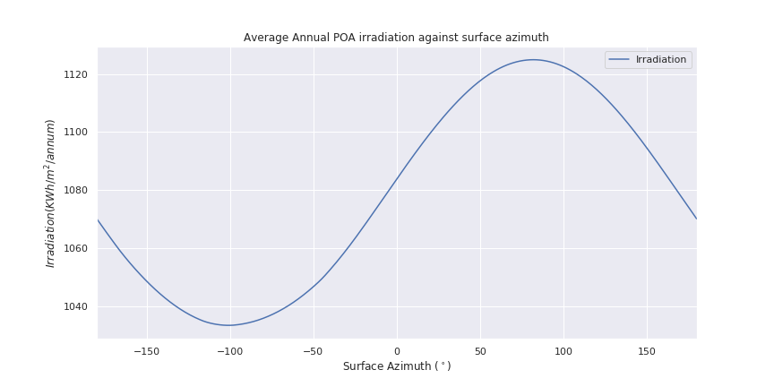

Figure 4:10 Average Annual irradiation for different surface azimuth angles in Kampala

When the surface is inclined at 5 degrees from horizontal in the region near the equator in northern hemisphere like Kampala , the average annual irradiation begins to increase as the surface is oriented away from east at sun rise towards west at sun set. The average irradiation is maximum at 82 degrees from south towards west and corresponding irradiation is 1121Wh//annum. For surfaces in regions near the equator tilted from the horizontal, the optimum surface azimuth is 82 degrees to yield maximum average annual irradiation.

## 

Figure 4:11 Average Annual irradiation for different surface azimuth angles in Lira

When the surface is inclined at 5 degrees from horizontal in the region away from the equator in northern hemisphere like Lira which is in northern Uganda, the average annual irradiation begins to decrease as the surface is oriented away from east at sun rise towards west at sun set. The average irradiation is maximum at 69 degrees from south towards east and corresponding irradiation is 1573Wh//annum. For surfaces in regions away from the equator tilted from the horizontal, the optimum surface azimuth is 69 degrees that yield maximum average annual irradiation.

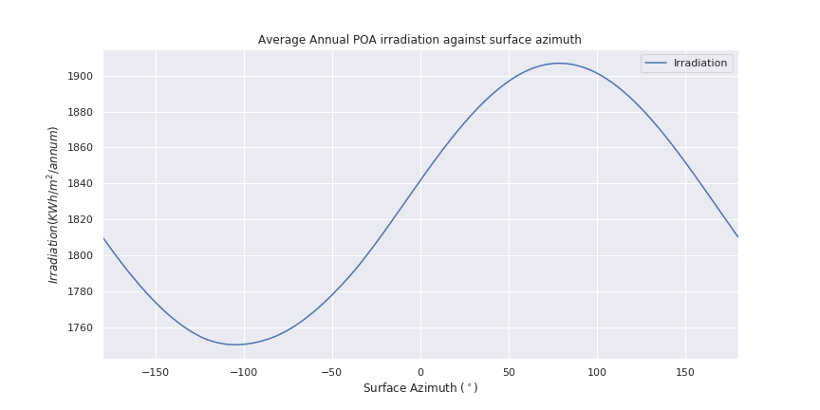

Figure 4:12 Average annual irradiation for different Surface azimuth angles in Tororo

When the surface is inclined at 5 degrees from horizontal in the region away from the equator in Eastern Region of Uganda in northern hemisphere like Tororo , the average annual irradiation begins to increase as the surface is oriented away from east at sun rise towards west at sun set. The average irradiation is maximum at 79 degrees from south towards west and corresponding irradiation is 1892Wh//annum. For surfaces in regions away from the equator tilted from the horizontal, the optimum surface azimuth is 79 degrees that yield maximum average annual irradiation.

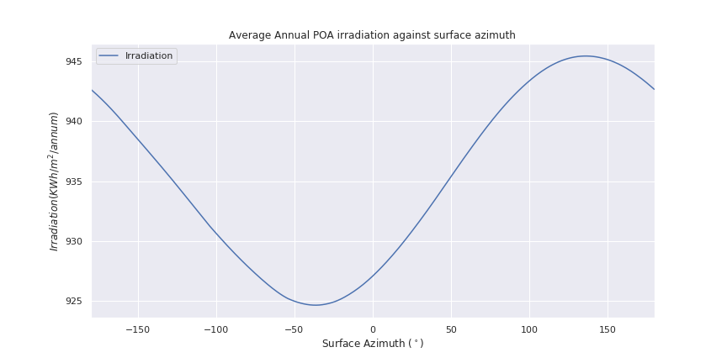

Figure 4:13 Average annual irradiation for different Surface azimuth angles in Mbarara

When the surface is inclined at 1 degree from horizontal in the region near the equator in southern hemisphere like Mbarara, the average annual irradiation begins to increase as the surface is oriented away from east at sun rise towards west at sun set. The average irradiation is maximum at 137 degrees from south towards west and corresponding irradiation is 961Wh//annum. For surfaces in regions near the equator tilted from the horizontal, the optimum surface azimuth is 137 degrees that yield maximum average annual irradiation.

## 4.5 Adjusting both Collector Tilt and Surface Azimuth Angles

The collector tilt angle and surface azimuth angle were adjusted at the same time while computing average annual solar irradiation. The pair of collector tilt and surface azimuth with maximum average annual solar irradiation was obtained and corresponding average annual irradiation for different areas. The surface plots of average annual irradiation against collector tilt and surface azimuth angles for different regions are shown below.

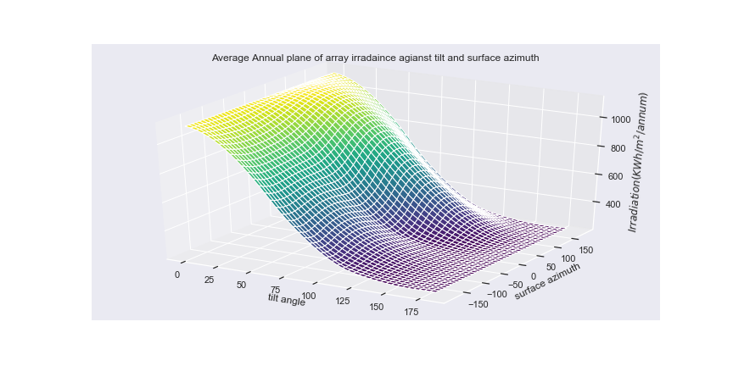

Figure 4:14 Average annual irradiation against tilt angle and surface azimuth in Kampala

The surface in regions near the equator in northern hemisphere like Kampala, the optimum surface tilt and surface azimuth is 11 and 82 degrees respectively and corresponding irradiation of 1126Wh//annum with an increase of 1.3% in irradiation compared with surfaces facing south and flat. This archives two goals of gaining maximum irradiation and tilting the collector for self-cleaning purpose.

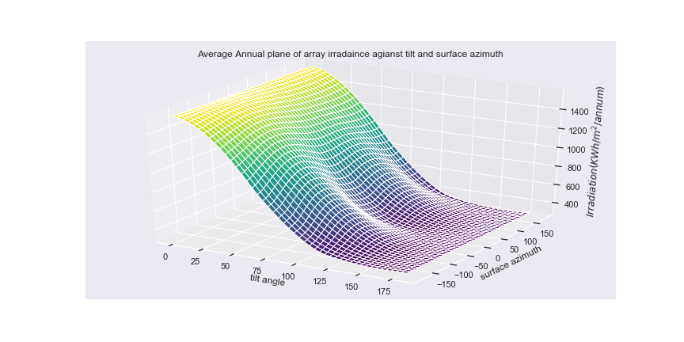

Figure 4:15 Average Annual Irradiation against tilt angle and Surface azimuth in Lira

The surface in regions away from the equator in northern hemisphere in Northern parts of Uganda like Lira, the optimum surface tilt and surface azimuth is 4 and -69 degrees respectively and corresponding irradiation of 1573Wh//annum with an increase of 0.2% in irradiation compared with surfaces facing south and flat. This archives two goals of gaining maximum irradiation and tilting the collector for self-cleaning purpose

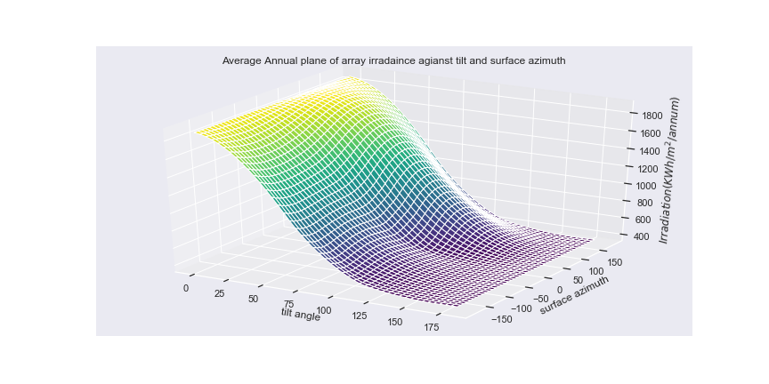

Figure 4:16 Average Annual Irradiation against tilt angle and Surface azimuth in Tororo

The surface in regions away from the equator in northern hemisphere in Eastern Region of Uganda like Tororo, the optimum surface tilt and surface azimuth is 11 and 79 degrees respectively and corresponding irradiation of 1900Wh//annum with an increase of 1.4% in irradiation compared to surfaces facing south and flat. This archives two goals of gaining maximum irradiation and tilting the collector for self-cleaning purpose

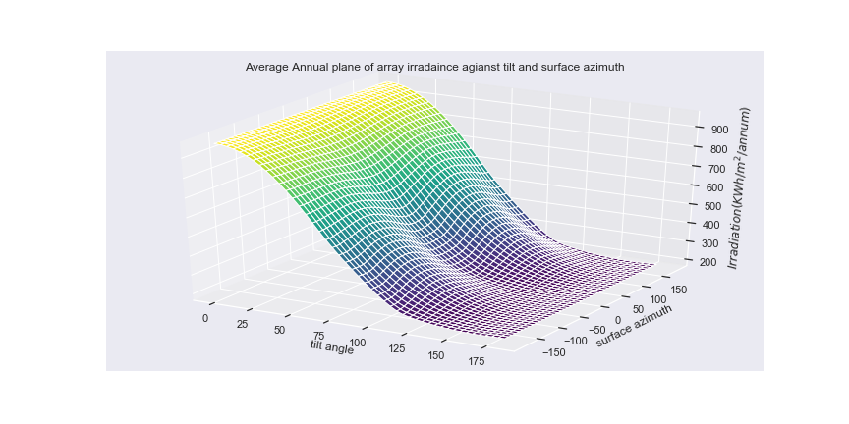

Figure 4:17 Average Annual Irradiation against tilt angle and Surface azimuth in Mbarara

The surface in regions near the equator in southern hemisphere like Mbarara, the optimum surface tilt and surface azimuth is 1 and 138 degrees respectively and corresponding irradiation of 963Wh//annum with an increase of 0.1% in irradiation for surfaces facing south and flat. This archives two goals of gaining maximum irradiation and tilting the collector for self-cleaning purpose.

## 4.7 Sun Hours for different regions

|  |  |
| --- | --- |
| Region | Average daily sun hours |
| Kampala | 4.5 |
| Tororo | 5.4 |
| Lira | 7.6 |
| Mbarara | 6.8 |

## 4.8 Summary of Results from Analysis

The finding reveals that the combinations which involved decomposition models which were developed from other arears performed poorly on basis of rRMSD. The best performing combination of models involved clear-sky model of Duffie and Beckman, decomposition model (**model 1**) which was developed using local datasets and transposition model of Perez. This combination had rMBD and rRMSD of 2.55% and 35.5% respectively.

For regions and north of the equator, the optimum collector tilt and surface azimuth is about 11 and 82 degrees respectively that yield maximum irradiation. The optimum tilt and surface azimuth for regions which lie in northern hemisphere is 8.67 and 30.67 degrees respectively. By facing collector away from south, the increase in annual irradiation ranges between 0.1% to 1.4% at optimum surface azimuth.

# 5.0 CONCLUSION AND RECOMMENDATIONS

## 5.1 Conclusion

The findings Cleary shows that for the regions near the equator and facing south in northern hemisphere, an increase in tilt angle results in loss of solar irradiation. The maximum irradiation occurs at about 82 degrees away from south towards west and 11 degrees tilt which is contrary to most of the literature claims that for regions near the equator must orient their surfaces towards south with tilt angle of zero.

The decomposition model which was developed from datasets collected from different sites around Uganda that splits global horizontal irradiance into beam and diffuse horizontal irradiance was totally different from the decomposition models that was developed by Erbs, orgil and Holland’s in areas around United States from America. The combination models that involved these foreign models to predict plane of array performed poorly on basis of rRMSD compared to the combination of models that involved the decomposition model that was developed using local datasets.

The combination of models that involves the decomposition model which was developed using local data sets performed well compared to others and the combination which involved Hay and Davis or Perez transposition model also performed well with rMSRD between 35%-36% compared to lie and Jordan transposition model with had rMSRD of about 45%

This analysis of developing combination of models to predict plane of array irradiance revealed that optimal parameters that yield maximum insolation does not necessarily occur for surfaces facing south which are almost flat for regions near equator as inferred from most literature but it occurs at about 82 degrees away from south towards west and 11 degrees tilt. These findings will enable the developers to orient their collectors at optimum parameters of about 30.67 degrees surface azimuth and 8.67 degrees tilt angle for any region in Uganda in northern hemisphere while yielding maximum solar irradiation which commensurate with profits generated by the plant

## 5.1 Recommendations

* The hourly solar irradiance from different regions of the Country should be incorporated in future development of decomposition of the model to fully capture different climate conditions around the country.
* Developers setting up plants should collect data for at least one year from the region of interest and the then use the developed combination model to get optimum parameters for that region.
* Collectors near the equator any facing south, should be flat to gain maximum irradiation per year because in increase in tilt angle results in loss of energy.
* There is a need to collect more data from regions in southern hemisphere for Uganda to capture climate changes from those regions

# APPENDIX

| Date_time | Horizontal Irradiance | BHI | PoA Irradiance 30 | PoA Irradiance 15 | PoA Irradiance 22.5 |
| --- | --- | --- | --- | --- | --- |
| 2011-04-05 00:00:00+03:00 | 0 | 0 | 0 | 0 | 0 |
| 2011-04-05 10:00:00+03:00 | 234 | 234 | 213 | 223 | 0 |
| 2011-04-05 11:00:00+03:00 | 785 | 663 | 715 | 751 | 0 |
| 2011-04-05 12:00:00+03:00 | 972 | 648 | 889 | 930 | 0 |
| 2011-04-05 13:00:00+03:00 | 777 | 318 | 713 | 739 | 0 |
| 2011-04-05 14:00:00+03:00 | 573 | 241 | 521 | 536 | 0 |
| 2011-04-05 15:00:00+03:00 | 761 | 613 | 670 | 687 | 0 |
| 2011-04-05 16:00:00+03:00 | 717 | 708 | 616 | 629 | 0 |
| 2011-04-05 17:00:00+03:00 | 475 | 475 | 394 | 399 | 0 |
| 2011-04-05 18:00:00+03:00 | 197 | 197 | 155 | 157 | 0 |
| 2011-04-05 19:00:00+03:00 | 51 | 51 | 35 | 35 | 0 |
| 2011-04-05 20:00:00+03:00 | 0 | 0 | 0 | 0 | 0 |
| 2011-04-05 21:00:00+03:00 | 0 | 0 | 0 | 0 | 0 |
| 2011-04-05 22:00:00+03:00 | 0 | 0 | 0 | 0 | 0 |
| 2011-04-05 23:00:00+03:00 | 0 | 0 | 0 | 0 | 0 |
| 2011-04-06 00:00:00+03:00 | 0 | 0 | 0 | 0 | 0 |
| 2011-04-06 01:00:00+03:00 | 0 | 0 | 0 | 0 | 0 |
| 2011-04-06 02:00:00+03:00 | 0 | 0 | 0 | 0 | 0 |
| 2011-04-06 03:00:00+03:00 | 0 | 0 | 0 | 0 | 0 |
| 2011-04-06 04:00:00+03:00 | 0 | 0 | 0 | 0 | 0 |
| 2011-04-06 05:00:00+03:00 | 0 | 0 | 0 | 0 | 0 |
| 2011-04-06 06:00:00+03:00 | 0 | 0 | 0 | 0 | 0 |
| 2011-04-06 07:00:00+03:00 | 0 | 0 | 0 | 0 | 0 |
| 2011-04-06 08:00:00+03:00 | 48 | 10 | 45 | 45 | 0 |
| 2011-04-06 09:00:00+03:00 | 162 | 5 | 148 | 148 | 0 |
| 2011-04-06 10:00:00+03:00 | 332 | 25 | 310 | 311 | 0 |
| 2011-04-06 11:00:00+03:00 | 682 | 318 | 635 | 653 | 0 |
| 2011-04-06 12:00:00+03:00 | 892 | 545 | 810 | 845 | 0 |
| 2011-04-06 13:00:00+03:00 | 945 | 433 | 847 | 887 | 0 |
| 2011-04-06 14:00:00+03:00 | 675 | 306 | 604 | 625 | 0 |
| 2011-04-06 15:00:00+03:00 | 718 | 382 | 647 | 659 | 0 |
| 2011-04-06 16:00:00+03:00 | 276 | 107 | 252 | 253 | 0 |
| 2011-04-06 17:00:00+03:00 | 598 | 485 | 513 | 518 | 0 |
| 2011-04-06 18:00:00+03:00 | 334 | 334 | 274 | 275 | 0 |
| 2011-04-06 19:00:00+03:00 | 61 | 61 | 47 | 48 | 0 |
| 2011-04-06 20:00:00+03:00 | 0 | 0 | 0 | 0 | 0 |
| 2011-04-06 21:00:00+03:00 | 0 | 0 | 0 | 0 | 0 |
| 2011-04-06 22:00:00+03:00 | 0 | 0 | 0 | 0 | 0 |
| 2011-04-06 23:00:00+03:00 | 0 | 0 | 0 | 0 | 0 |
| 2011-04-07 00:00:00+03:00 | 0 | 0 | 0 | 0 | 0 |
| 2011-04-07 01:00:00+03:00 | 0 | 0 | 0 | 0 | 0 |
| 2011-04-07 02:00:00+03:00 | 0 | 0 | 0 | 0 | 0 |
| 2011-04-07 03:00:00+03:00 | 0 | 0 | 0 | 0 | 0 |
| 2011-04-07 04:00:00+03:00 | 0 | 0 | 0 | 0 | 0 |
| 2011-04-07 05:00:00+03:00 | 0 | 0 | 0 | 0 | 0 |
| 2011-04-07 06:00:00+03:00 | 0 | 0 | 0 | 0 | 0 |
| 2011-04-07 07:00:00+03:00 | 1 | 1 | 1 | 1 | 0 |
| 2011-04-07 08:00:00+03:00 | 35 | 10 | 32 | 32 | 0 |
| 2011-04-07 09:00:00+03:00 | 96 | 4 | 82 | 85 | 0 |
| 2011-04-07 10:00:00+03:00 | 126 | 10 | 107 | 111 | 0 |
| 2011-04-07 11:00:00+03:00 | 239 | 4 | 218 | 222 | 0 |
| 2011-04-07 12:00:00+03:00 | 403 | 50 | 375 | 383 | 0 |
| 2011-04-07 13:00:00+03:00 | 736 | 98 | 680 | 696 | 0 |
| 2011-04-07 14:00:00+03:00 | 766 | 260 | 694 | 712 | 0 |
| 2011-04-07 15:00:00+03:00 | 673 | 373 | 606 | 619 | 0 |
| 2011-04-07 16:00:00+03:00 | 674 | 536 | 587 | 596 | 0 |
| 2011-04-07 17:00:00+03:00 | 543 | 517 | 455 | 462 | 0 |
| 2011-04-07 18:00:00+03:00 | 316 | 316 | 253 | 258 | 0 |
| 2011-04-07 19:00:00+03:00 | 73 | 73 | 56 | 58 | 0 |
| 2011-04-07 20:00:00+03:00 | 0 | 0 | 0 | 0 | 0 |
| 2011-04-07 21:00:00+03:00 | 0 | 0 | 0 | 0 | 0 |
| 2011-04-07 22:00:00+03:00 | 0 | 0 | 0 | 0 | 0 |
| 2011-04-07 23:00:00+03:00 | 0 | 0 | 0 | 0 | 0 |
| 2011-04-08 00:00:00+03:00 | 0 | 0 | 0 | 0 | 0 |
| 2011-04-08 01:00:00+03:00 | 0 | 0 | 0 | 0 | 0 |
| 2011-04-08 02:00:00+03:00 | 0 | 0 | 0 | 0 | 0 |
| 2011-04-08 03:00:00+03:00 | 0 | 0 | 0 | 0 | 0 |
| 2011-04-08 04:00:00+03:00 | 0 | 0 | 0 | 0 | 0 |
| 2011-04-08 05:00:00+03:00 | 0 | 0 | 0 | 0 | 0 |
| 2011-04-08 06:00:00+03:00 | 0 | 0 | 0 | 0 | 0 |
| 2011-04-08 07:00:00+03:00 | 0 | 0 | 0 | 0 | 0 |
| 2011-04-08 08:00:00+03:00 | 6 | 3 | 5 | 5 | 0 |
| 2011-04-08 09:00:00+03:00 | 5 | 3 | 5 | 5 | 0 |

# BIBLIOGRAPHY

[1] G. E. and C. Statistics, “GECO.” [Online]. Available: https://www.iea.org/geco/. [Accessed: 16-Oct-2018].

[2] D. M. R. Perez, R. Seals, P. Ineichen, R. Stewart, “A new simplified version of the perez diffuse irradiance model for tilted surfaces,” *Sol. Energy*, vol. 39, no. 3, pp. 221–231, 1987.

[3] J. Hay and J. Davies, “Calculation of monthly mean solar radiation for horizontal and inclined surfaces,” *Sol. Energy*, vol. 23, pp. 301–307, 1979.

[4] T. M. Klucher, “Evaluation of models to predict insolation on tilted surfaces,” *Sol. Energy*, vol. 23, no. 2, pp. 111–114, 1979.

[5] J. A. D. D. G. Erbs, S. A. Klein, “Estimation of the diffuse radiation fraction for hourly, daily and monthly-average global radiation,” *Sol. Energy*, vol. 28, no. 4, pp. 293–302, 1982.

[6] J. A. Duffie and W. A. Beckman, *Solar Engineering of Thermal Processes*, Fourth Edi. Canada, 2013.

[7] P. G. Loutzenhiser, H. Manz, C. Felsmann, P. A. Strachan, T. Frank, and G. M. Maxwell, “Empirical validation of models to compute solar irradiance on inclined surfaces for building energy simulation,” *Sol. Energy*, vol. 81, no. 2, pp. 254–267, 2007.

[8] M. Lave, “Evaluation of Global Horizontal Irradiance to Plane of Array Irradiance Models at Locations across theUnited States,” *IEEE J. Photovoltaics*, vol. 5, no. 2, p. 2, 2015.

[9] PVEducation, “Solar Radiation on a Tilted Surface.” [Online]. Available: https://www.pveducation.org/pvcdrom/properties-of-sunlight/solar-radiation-on-a-tilted-surface. [Accessed: 06-Nov-2018].

[10] J. F. O. and K. G. T. Hollands, “Correlation equation for hourly diffuse radiation on a horizontal surface,” *Sol. Energy*, vol. 19, no. 4, pp. 357–359, 1977.

[11] E. L. Maxwell, “A quasi-physical model for converting hourly global horizontal to direct normal insolation,” *Sol. Energy Res. Inst.*, 1987.

[12] R. Perez, “Dynamic global to direct conversion models,” *ASHRAE Trans. Res. Ser.*, pp. 154–168, 1992.

[13] J. S. M. Reno, C. Hansen, “Global Horizontal Irradiance Clear Sky Models: Implementation and Analysis,” 2012.

[14] B. Y. H. L. and R. C. Jordan, “The interrelationship and characteristic distribution of direct, diffuse and total solar radiation,” *Sol. Energy*, vol. 4, no. 3, pp. 1–19, 1960.

[15] C. Demain, M. Journée, and C. Bertrand, “Evaluation of different models to estimate the global solar radiation on inclined surfaces,” *Renew. Energy*, vol. 50, pp. 712–713, 2013.

[16] R. Perez, R. Stewart, R. Seals, and T. Guertin, “The Development and Verification of the Perez Diffuse Radiation Model,” *Sandia Natl. Labs. Albuquerque, NM, USA; State Univ. New York Albany, NY, USA*, no. October, 1988.

[17] PhysicalGeography.net, “6(h). Earth-Sun Geometry.” [Online]. Available: http://www.physicalgeography.net/fundamentals/6h.html. [Accessed: 02-Dec-2018].

[18] P. I. Cooper, “The Absorption of Solar Radiation in Stills,” *Sol. Energy*, vol. 12, no. 3, 1969.

[19] Jordan University of Scince and Technology, “The angular displacement from south of the projection of beam radiation on the.” [Online]. Available: https://www.coursehero.com/file/p6phfq8/The-angular-displacement-from-south-of-the-projection-of-beam-radiation-on-the/. [Accessed: 02-Dec-2018].

[20] E. Tasdemiroglu, “Solar Energy Utilization Technical and Economic Aspects,” *Middle East Tec. Univ.*

[21] universit of Sharjah, “Solar Radiation Instantaneous solar radiation on a tilted surface Ic c r c d c.” [Online]. Available: https://www.coursehero.com/file/p4d0e6un/Solar-Radiation-Instantaneous-solar-radiation-on-a-tilted-surface-Ic-c-r-c-d-c/. [Accessed: 25-Oct-2018].

[22] Quizlet, “SOLAR ENERGY Flashcards.” [Online]. Available: https://quizlet.com/111976835/solar-energy-flash-cards/. [Accessed: 25-Oct-2018].

[23] ASCE, “American Society of Civil Engineers.” [Online]. Available: https://www.asce.org/. [Accessed: 25-Oct-2018].

[24] Plant Predict, “Irradiance &amp; Radiation.” [Online]. Available: https://plantpredict.com/algorithm/irradiance-radiation/. [Accessed: 02-Dec-2018].

[25] J. W. Spencer, “Fourier Series Representation of the Position of the Sun,” *Sundial List*, vol. 2, p. 172, 1971.

[26] S. A. K. D. G. Erbs, J. A. Duffi, “Estimation of the diffuse radiation fraction for hourly, daily and monthly-average global radiation,” *Sol. Energy*, vol. 28, pp. 293–302, 1982.

[27] M. Boland, J. Scott, L. Luther, “Modelling the diffuse fraction of global solar radiation on a horizontal surface,” *Environmetrics*, vol. 12, pp. 103–116, 2001.

[28] Muneer. T, “Correlation between hourly diffuse and Energy Convers. Manag,” *Radiat. G*, vol. 24, pp. 265–267, 1984.

[29] Liu. B and Jordan. R, “Daily insolation on surfaces tilted towards equator,” *ASHRAE J.; (United States)*, vol. 10, pp. 53–59, 1961.

[30] T. Perez, R.; Stewart, R.; Seals, R.; Guertin, “The Development and Verification of the Perez Diffuse Radiation Model,” *Sandia Natl. Labs. Albuquerque, NM, USA; State Univ. New York Albany, NY, USA*, 1988.

[31] R. Perez, R.; Ineichen, P.; Seals, R.; Michalsky, J.; Stewart, “Modeling Daylight Availability and Irradiance Components from Direct and Global Irradiance,” *Sol. Energy*, vol. 44, pp. 271–289, 1990.

[32] G. Dietze, “Einführung in die Optik der Atmosphäre,” *Leipzig, Akad. Verlagsgesellschaft Geest Portig K.G*, 1957.

[33] Geymard, “Direct and indirect uncertainties in the prediction of tilted irradiance for solar engineering applications,” *Sol. Energy*, vol. 83, pp. 432–444.

[34] scikit-learn, “machine learning in Python — scikit-learn 0.20.2 documentation.” [Online]. Available: https://scikit-learn.org/stable/. [Accessed: 06-Feb-2019].

[35] Wes McKinney, “Python Data Analysis Library — pandas: Python Data Analysis Library.” [Online]. Available: https://pandas.pydata.org/. [Accessed: 06-Feb-2019].

[36] V. Quaschning, *Understanding Renewable Energy Systems*. UK and USA: Earthscan, 2005.

1. This is the total radiation incident and normal to the surface which is tilted with respect to the ground
2. This is solar radiation from the sun which has been scattered and reflected by atmosphere
3. resulting from forward scattering of solar radiation
4. This is angular displacement of projection of surface line from south on horizontal plane
5. This is solar radiation from the sun which its direction is not changed by scattering and reflection of atmosphere.
6. This is the total radiation power incident on horizontal plane
7. when the sun is on the local meridian